SUBMITTED TO SKILLOVILLA UNDER POWER BI CAPSTONE PROJECT.

**SHOPNEST STORE CAPSTONE PROJECT**

A COMPREHENSIVE REPORT



BY RASHMI SHARMA

**ABOUT SHOPNEST**

ShopNest is an online shopping destination that offers a wide range of products, easy navigation, and good customer service. Their mission is to provide a seamless and enjoyable shopping experience for customers.

ShopNest stands as the leading department store in the e-commerce marketplace in Portugal. Serving as a seamless link, it connects small businesses from various regions in Portugal to channels, streamlining the process with a single point of contact. Through the ShopNest store, these merchants can showcase and sell their products, with the added convenience of direct shipment to customers with ShopNest logistics partner.

1. **Rating distribution**

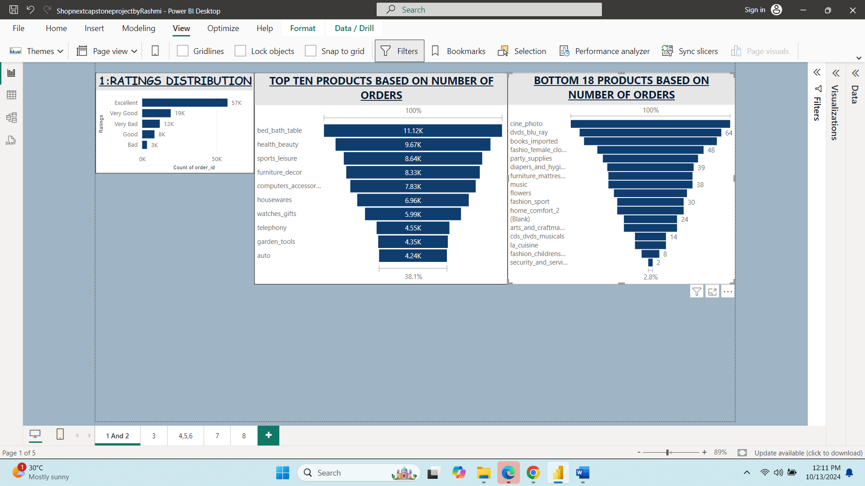

The rating distribution visualization provides insight into customers satisfaction levels, highlighting the distribution of ratings across Excellent, Very Good, Good, Bad and Very Bad.

* Excellent Ratings have the largest share indicating a strong customer satisfaction baseline.
* Very Good have 19K ratings suggesting a significant portion of customers are pleased with the services.
* Moderate level of satisfaction is indicated by good rating.
* 3000 Bad ratings highlighting room for improvement.
* 12000 Very bad Ratings indicating a significant area for concern.

Insights and Recommendations

* Majority of the customers are extremely satisfied indicating effective service delivery.
* Focus should be on maintain excellent services to retain satisfied customers.
* Need to address the 12k very bad and 3 K bad ratings to improve overall customer experience.
* Monitor Good Ratings to identify areas for incremental improvements.

1. **Top Ten most Popular products based on order numbers**

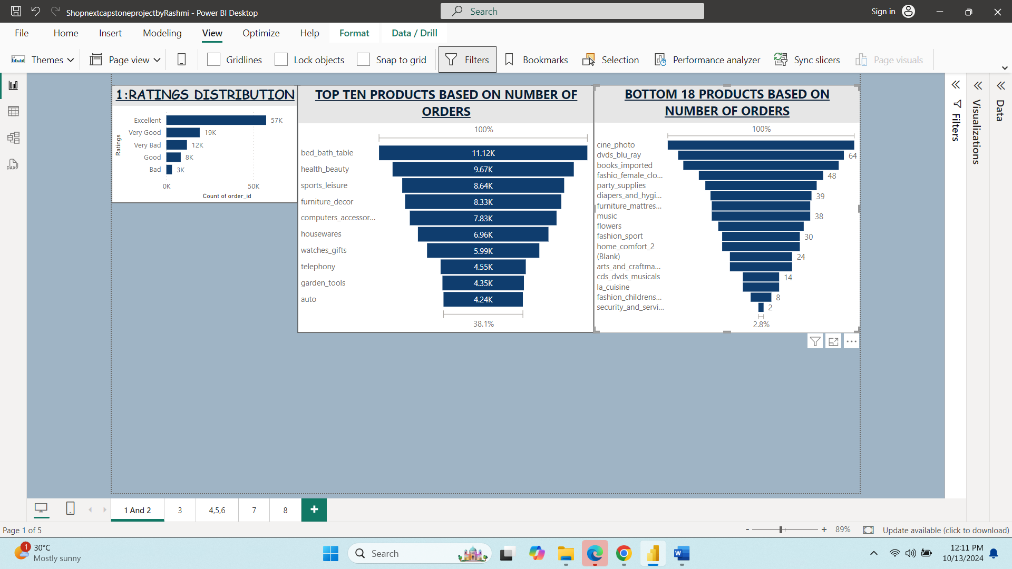

Above mentioned products have received the highest demand, driving business growth making them the clear best seller and they contribute significantly to overall revenue. We need to focus on marketing efforts for these products.

1. **Bottom Eighteen products based on order numbers**

These are the bottom 10 products and they account for very less percentage of total orders and they contribute minimally to overall revenue.

* Consider revising marketing strategies.
* Analyze customer Feedback to improve underperforming products.
* Consider bundling or discounting low-demand products.

1. **Year-Wise Active Sellers**

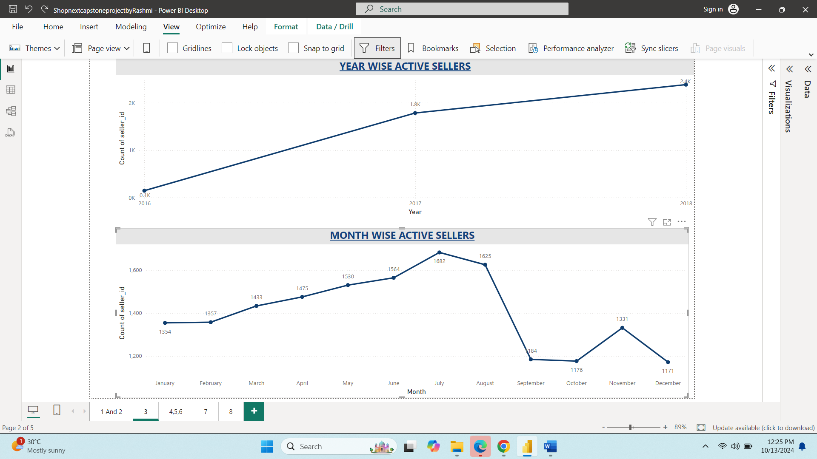

This analysis highlights the number of active sellers per year indicating growth in the seller base. The number of active sellers has demonstrated significant growth over the years.

1. **Month-Wise Active Sellers**



This analysis provides insights into the monthly fluctuations of active sellers.

Key insights

* Peak months: July (1682), June (1564), and May (1530).
* Lowest Month: September (184), indicating a significant decline.
* Consistent growth from Jan to July.
* Fluctuation from August to December.

1. **Commonly Used Payment Methods**

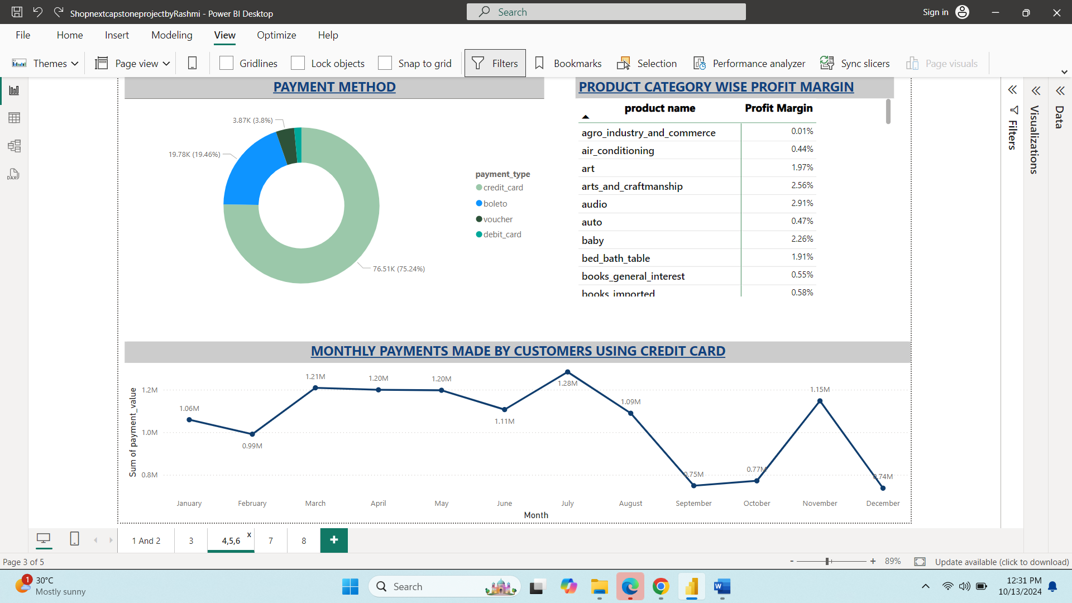

This analysis highlights the most commonly used payment methods.

Key Insights

* Credit card dominate the payment landscape accounting for 75.24% of transactions.
* Boleto is the second most popular method with 19.46% of transactions.
* Vouchers represent a small but notable 3.8% transactions.
* Only fewer number of customers prefer debit cards for payments.

**7.Product category wise Profit Margin**



Above table provides information about product category wise profit margin.

A strong profit margin drives business growth and sustainablity.

1. **Monthly Payments made by using Credit card**



This analysis highlights the monthly credit card payments trends.

Key insights.

* Peak months: July,March,April and May.
* Lowest months : September,October and December.
* Consistent payment above 1M from March to August.

1. **City wise seller count Excluding cities starting with ‘S’ and ‘B’**

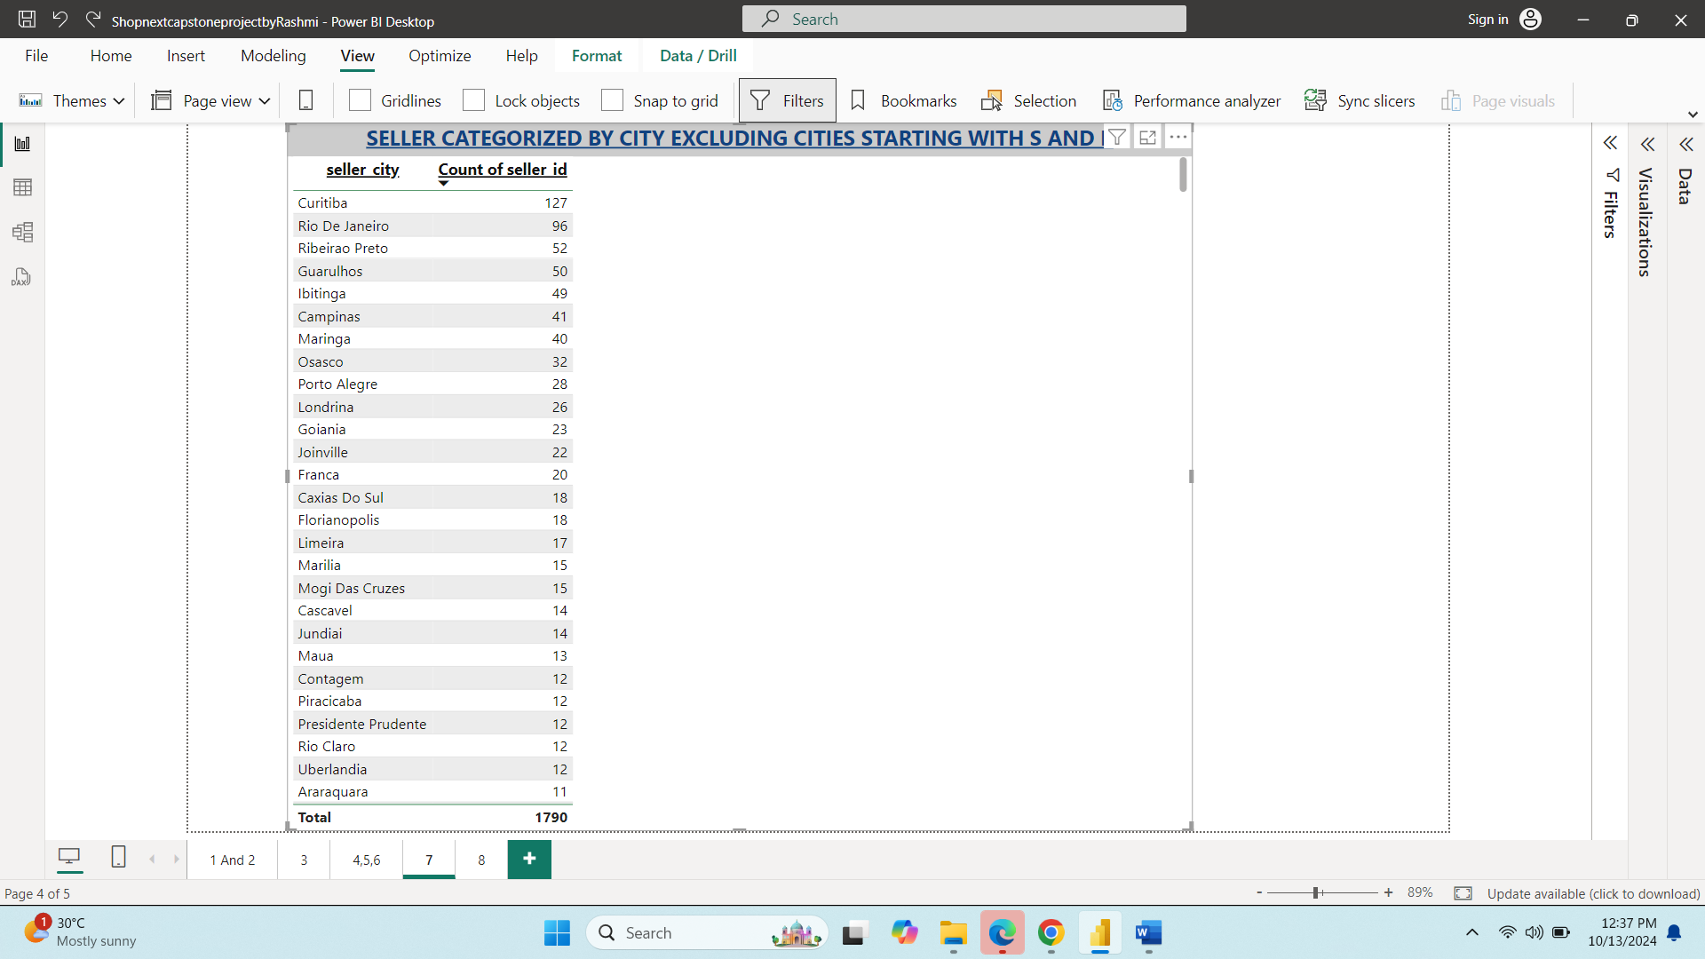

This analysis highlights City-wise seller count (Excluding Cities starting with S and B)

**Total sellers =1790**

Key Insights

* Curitiba leads with 127 sellers (7.1% of total)
* Araraquara has the fewest sellers with 11(0.6% of total)

Recommendations

* Focus expansion efforts on underrepresented cities.
* Analyze factors driving Curitiba’s high seller count.
* Develop strategies to support growth in smaller cities.

**10. Delayed orders and On-Time orders Month-Wise.**

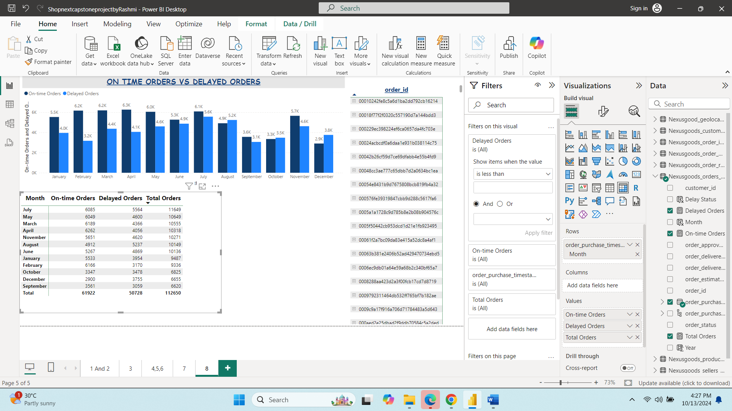



This analysis highlights the number of delayed and on-time orders month-wise.

Overall Performance

* Total Orders:112650
* Total On-time Orders:61922(54.9% of total orders)
* Total delayed Orders:50728(45.1% of total orders)
* Peak season for orders is July (11649 total orders)
* Low season for orders is September (6620 total orders)

Monthly Trends

* Best month for on-time orders is February (66.1% on-time rate)
* Worst month for on-time orders is December (43.6% on-time rate)
* Highest number of delayed orders is in July (5564)
* Lowest number of delayed orders September (3059)

Key Insights

* On-time rates have decreased over the year, from 66.1% in February to 43.6% in December.
* Delayed orders have increased over the year from 3170 in February to 3755 in December.